Explanation of the Tsukamoto Fuzzy Inference System
1. Fuzzification Process
Fuzzification is the process of converting crisp input values (numerical data) into fuzzy membership degrees that express the degree to which each input belongs to various linguistic categories (e.g., Low, High).
Input Variables
- Speed (km/h) → Linguistic terms: Low, Medium, High
- Distance (m) → Linguistic terms: Near, Far
Membership Function Shapes
Each linguistic variable is defined using monotonic or triangular membership functions:
- Low / Near → Descending functions (membership decreases as value increases)
- High / Far → Ascending functions (membership increases as value increases)
For example:
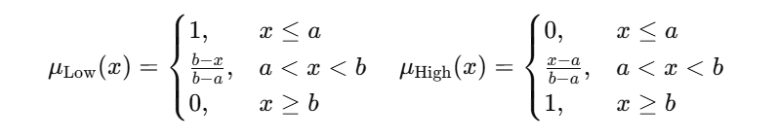
Example (75 km/h, 20 m):
- Speed(75 km/h):
→ μ_Low(Speed) = 0.00, μ_High(Speed) = 0.25
- Distance(20 m):
→ μ_Near(Distance) = 0.60, μ_Far(Distance) = 0.00
Hence, the system recognizes that the car is somewhat high speed and quite near the obstacle.

2. Rule Aggregation (Rule Base Construction)
The Tsukamoto FIS uses IF–THEN rules similar to classical fuzzy systems, but with monotonic consequents (outputs).
For the braking system, we define the rule base as follows:
Rule | IF Condition | THEN Conclusion
R1 | Speed is High AND Distance is Near | Brake Force is Strong
R2 | Speed is Medium AND Distance is Near | Brake Force is Strong
R3 | Speed is High AND Distance is Far | Brake Force is Medium
R4 | Speed is Low AND Distance is Near | Brake Force is Medium
R5 | Speed is Low AND Distance is Far | Brake Force is Light
R6 | Speed is Medium AND Distance is Far | Brake Force is Light
Each rule defines a relationship between the input states and the desired braking response.
Rules 1 and 2 correspond to strong braking, 3 and 4 to medium braking, and 5 and 6 to light braking.

3. Inference Mechanism (Rule Activation)
Each rule is activated to a degree determined by the fuzzy AND operator.
For Tsukamoto, the firing strength (αᵢ) of the i-th rule is computed as:
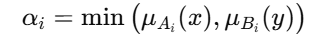
where:
- μAi(x) is the membership of the first input (Speed)
- μBi(y) is the membership of the second input (Distance)
Each rule’s firing strength represents how strongly that rule contributes to the final output.
Each rule’s firing strength represents how strongly that rule contributes to the final output.
Example (for 75 km/h, 20 m):
- R1: α₁ = min(μ_High(Speed), μ_Near(Distance)) = min(0.25, 0.60) = 0.25
- R2: α₂ = min(μ_Med(Speed), μ_Near(Distance)) = 0.50 (approx.)
- Other rules have α = 0 (because their inputs are inactive).

4. Consequent Evaluation (Monotonic Output Mapping)
Each rule’s output (Brake Force) is represented by a monotonic membership function:
- Light → Descending (0–50%)
- Medium → Ascending (30–70%)
- Strong → Ascending (60–100%)
In Tsukamoto inference, for each rule, we use the inverse of the output membership function to find a crisp z-value corresponding to the rule’s firing strength (αᵢ).
Thus:
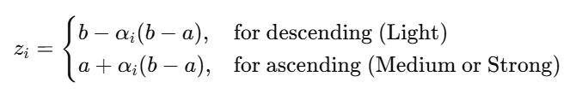
Example:
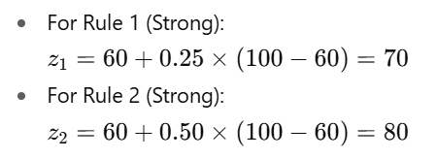

5. Defuzzification Strategy
The Tsukamoto system ensures that each rule produces a crisp output.
The final system output (Z*) is obtained using the weighted average of all crisp outputs, with the firing strengths as weights:
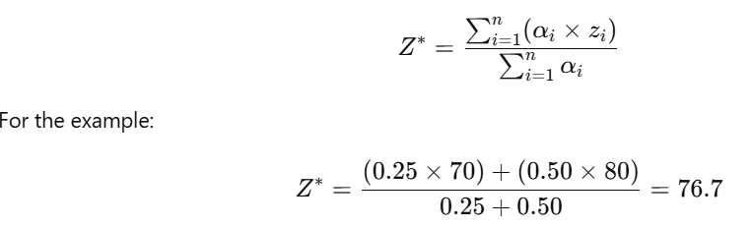
Hence, the final crisp output = 76.7% braking force.

